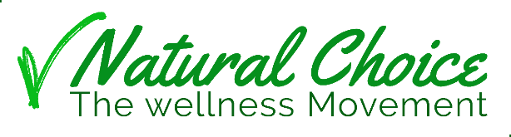

Welcome to
Natural Choice
MEMBER REVIEW

Life is all about Natural Choice

- Wellness is a natural choice.
- Success it is a natural choice.
- Fulfillment it's a natural choice.
- Rich social life is a natural choice.
- love is a natural choice.

what are your natural choices?

Our vision

Create a better world for us and for generations to came.

Our mission
To give people the opportunity to create Wellness life & financial freedom

We believe in you!
We believe that a Wellness life and financial freedom are a Natural Choice, we believe that anyone can do so if given the right opportunity.
We set up Natural Choice, The Wellness Movement Because We believe
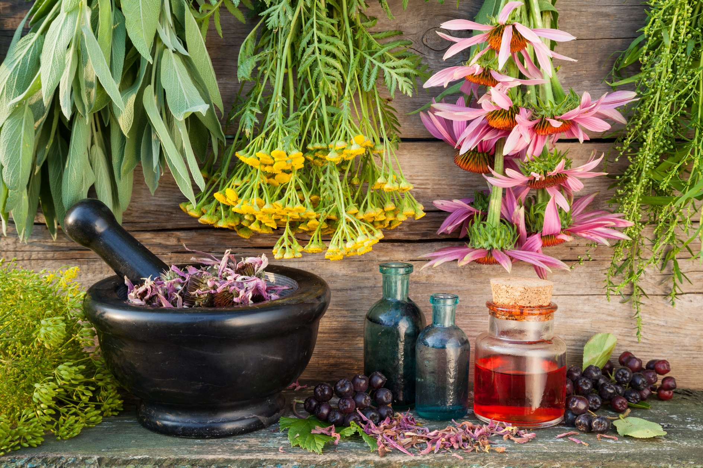

Natural Herbal Extracts

Natural Herbal have been used since the beginning of mankind for body, mind, and spiritual healing

Natural Herbal Extracts is a Unique Technology of extracting the active ingredient found in plants, with naturally a concentration of five times or more potency

Topical Patch Technology bring the Herbal Extracts to our body.
From the moment the patch is attached our skin, it starts the process of slow release, the active ingredient penetrates at a balanced pace straight into the bloodstream and brings the healing from the herbal to our body mind & spirt

Our Topical patch Products

The absorption of active ingredients from Natural Herbal through the skin directly into the bloodstream is an ancient technology that goes back to the beginning of humanity.

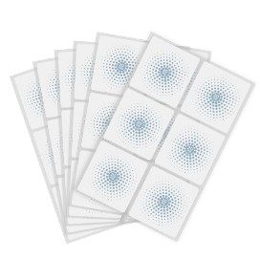

Use of ointments for physical and spiritual healing is recognized as a healing method in ancient cultures all over the world.

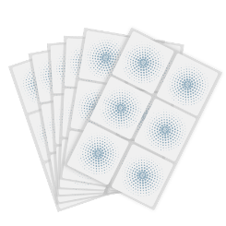

Topical Patch is an innovative development, adapted to modern life, which allows the injection of herbal extracts in high concentration, to release slowly throughout the day. We use the highest quality plant extracts in our products, and the most innovative Topical Patch technology especially for you.

We use the highest quality herbal extracts available in our products in the innovative Topical Patch technology especially for you.

Woman
Ingredients:
Mexican wild yam Extract
Valerian Root Extract
Hops Flower Extract
Lemon Balm
Black Cohosh Root Extract
Griffonia simplicifolia (5 HTP) Extra
Angelica sinensis Root Extract
Red Clove Extract
Curcumin Extract
licorice root Extract
Agnus Casus Extract
Turnera Diffusa (Damiana) Extract
Astragalus Membranaceus Extract
Ashwagandha Extract
Woman support product for all cycles of life.

Balance
Focus
Energy

Man
Ingredients:
Maca Root Extract
Epimedium Extract,
Guarana Extract
Astragalus Extract,
Ashwagandha Extract
Damiana Extract
Curcumin Extract
Grape Seed Extract
Supporting a man to face life's challenges

Performance
Alertness
Focus
Energy

Anti Aging

Ingredients:
Indian Gooseberry Extract
Curcumin Extract
Clove Extract
Ginger Root Extract,
Glutathione,
L-Carnitine,
Lecithin,
CoQ10,
NAC,
Nicotinamide Ridoside,
Alpha Lipoic Acid,
Grape Seed Extract,
Red Wine Extract,
Green Tea Extract
Herbal extracts, powerful natural antioxidants that help the body cope with the oxidative stress of the modern age

Q
Q
Herbal extracts that help alertness, focus, clear thinking, students and work around the clock
Focus

Ingredients:
Bacopa Monnieri (Brahmi) Extract
Centella Asiatica Extract Passionflower Extract
Ginseng Extract
Lemon Balm Extract
Lion's Mane Mushroom Extract

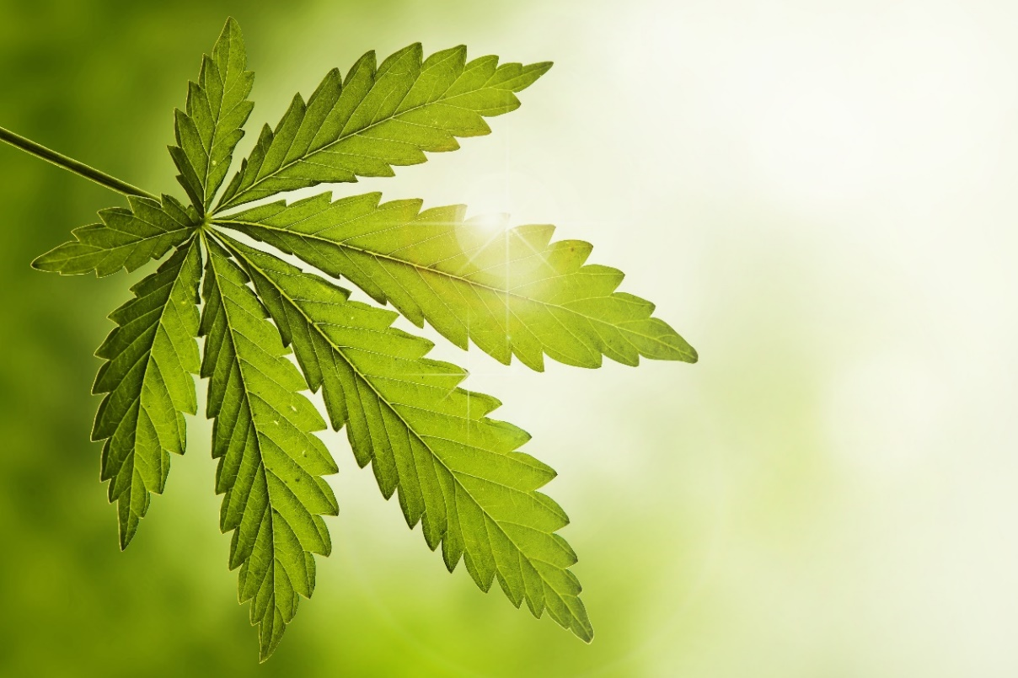
CBD Topical Patches with organic Cannabidiol
Reinforced using Natural Herbal Extract
Extremely effective, easy to use, slowly released over the course of at least 24 hours, high bioavailability.
CBD Plus

Topical Patches

Ingredients:
white willow bark Extract
Cat's Claw Extract
CoQ10,
Ashwagandha Extract
Acai Extract
With 15mg CBD (0% THC)

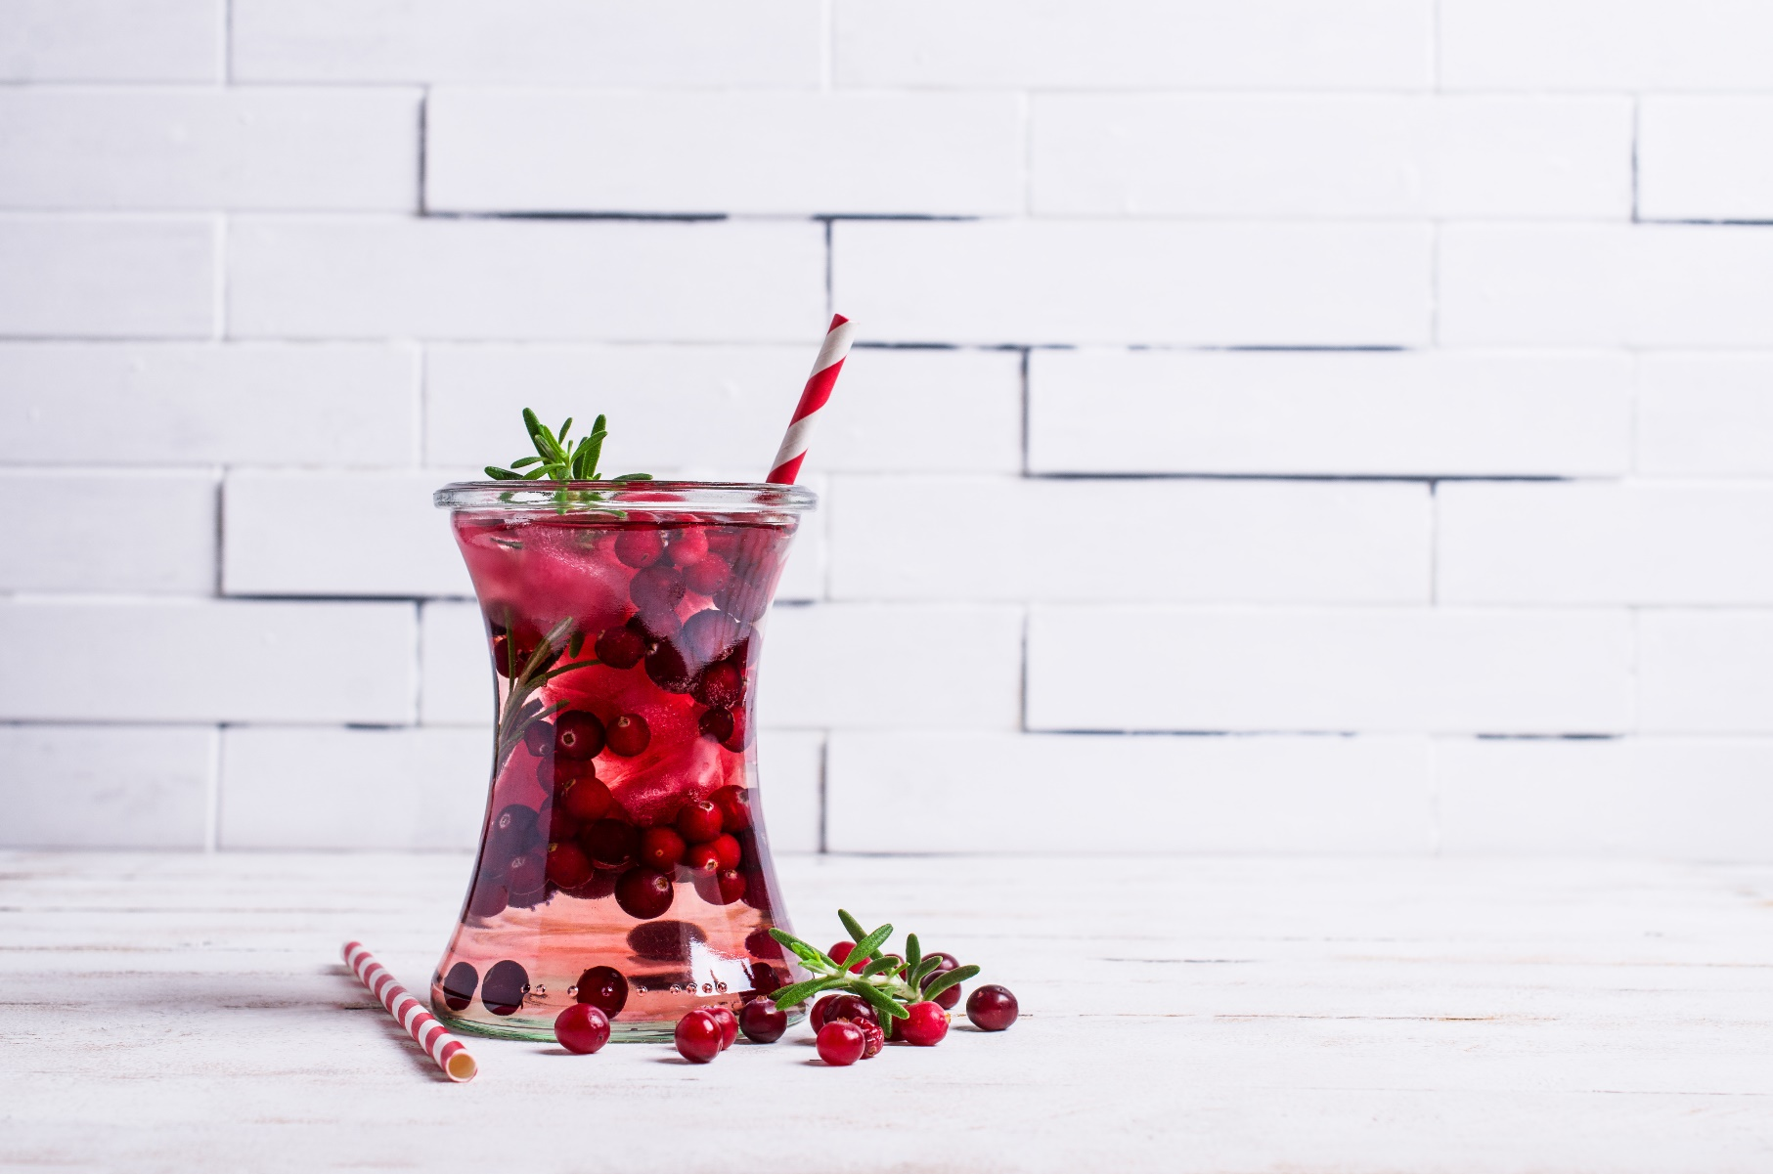
Full of vitamins, minerals and natural antioxidants. For general health and energy.
Anti-aging drink
Based on Natural Herbal Extracts

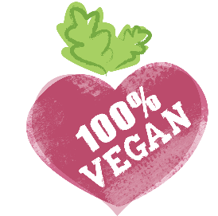

- Goji Berry Extract
- Moringa Extract
- Bakopa Extract
- Santala Extract
- Ashwagandha Extract
- Acai extract
- Pomegranate extracts

All in one bag (6 gm) for making a delicious and healthy drink, sweetened with Erythritol (0 calorific value)
A drink based on natural plant extracts, reduces the urge to eat excessively, increases metabolism, healthy and delicious
Weight management drink
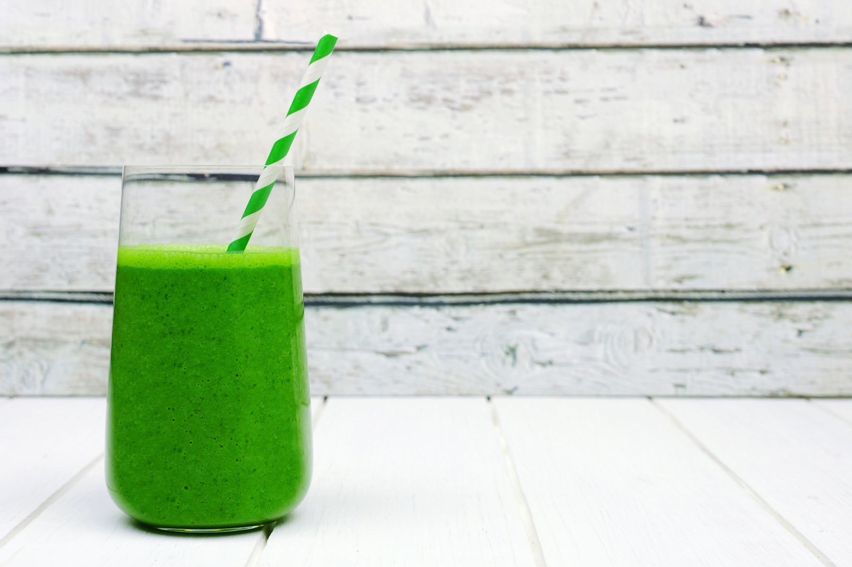

- Garcinia Cambogia Extract
- Green tea leaves extract
- Green coffee beans extract
- Cocoa Beans Extract
- Guarana Extract
- White bean extract

All in one bag (6 gm) for making a delicious and healthy drink, sweetened with Erythritol (0 calorific value)
To bring the world the gospel of Natural Herbal Technology
Our skin care Products

Let's move forward

Every great journey begins with one small step.

Start your journey to balanced health and financial freedom now!

First Step, purchase for yourself and your loved one a package of products that is right for you.
Start to use the wonderful Natural Herbal Technology products and share your experience with the world.

Help those people do the same and you will be able to earn increasing amounts of commission.

When a person you recommend makes a purchase, you will be entitled to a commission according to the compensation plan attached.

Keep earning as long as you are Active and as long as the network of consumers you have established is active, this is a possibility for you for many years to come

We are Establishing en ever expanding customer base.

You can set up a profitable international business all over the free world and Earn commissions many years ahead

Instead of investing in advertising and shelf space, we invest in people and a quality product.

Select your Start Up Package

Personal Packages
1 Business Center

Executive Packages
3 Business Center

Customer
1
1 product box of your choice, Customer price ($75) the right to enroll additional team members in all packages, earn commission according to the compensation plan, virtual back office and e-commerce site for social selling. 1 Business Center
4
Business
20 products boxes of your choice, Business price ($55) the right to enroll additional team members in all packages, earn commission according to the compensation plan, virtual back office e-commerce site for social selling. 3 Business Center

One Product Box $75 / 30CV
2
Each Product Box $55 / 30CV
Basic
All Products Pack $1,100 / 600CV
4 products boxes of your choice, Basic price ($65) the right to enroll additional team members in all packages, earn commission according to the compensation plan, virtual back office e-commerce site for social selling. 1 Business Center

Ambassador (best value)
5
30 product boxes of your choice, Ambassador price ($50) the right to enroll additional team members in all packages, earn commission according to the compensation plan, virtual back office e-commerce site for social selling. 3 Business Center

Each Product Box $65 / 30CV
All Products Pack $260 / 120CV

Each Product Box $50 / 30CV
All Products Pack $600 / 300CV
10 products boxes of your choice, Supreme price ($60) the right to enroll additional team members in all packages, earn commission according to the compensation plan, virtual back office e-commerce site for social selling. 1 Business Center
Each Product Box $60 / 30CV
Supreme
3
All Products Pack $1,500 / 900CV

Take a decision!

We design our lives by our decisions Tony Robbins

Definition: Every enrollee in each pack is a Team Member. Your startup package defines your business level, unless you have upgraded in one of the upgrade tracks listed on page 10 below
In order to be eligible to all commissions according to our compensation plan, your Business Center have to be Active.

Select your Monthly purchase

In order to Activate your Business Center, you have to set up a monthly purchase a minimum of 60CV each calandary month after your enrollment period, starting from the second calendar month of Enrollment.

In a calendar month that you have placed an order of 120CV or more you are active for the next two calandary months

During enrollment, the system will offer you to set up a monthly Auto Ship, where you can select your products for the next month. You can change or delete this automatic order at any time

Enrollment period: Starts on the day you enroll, ends at the end of the following calandary month. For example: if you enroll during January your enrollment period ends et end of February. During your enrollment period your business center is active, the first month for Auto Ship payment is during March

Automatic upgrade Tracks

Track 1: Upgrade during your Enrollment period: Buy the difference between startup packages and get automatic upgrade.

Track 2: Upgrade after your enrollment period , buy a full new Startup pack save your position and get an automatic upgrade.

Track 3: Upgrade step by step after your enrollment period: each month you purchase more than 60 CV the extra volume will accumulate for your upgrade.

Track 4: Upgrade by Enrolling a New Member: Enroll a New Member at any level. The new Team Member that you Enroll within 60 days of your Enrollment will be calculated for you to upgrade your subscription Startup pack.

Upgrade your life!

7 parallel ways to earn commissions
Compensation plan

- Retail profit.
- New Enrollment Commission.
- Team Volume Commission.
- Leveraged Matching Bonus.
- Star Bonuses.
- Consistency Rank Bonus.
- Leaders Pool Bonus.

1
Retail profit & Retail commission

Retail profit: Buy any product packages as a team Member discounted price:

Basic 4 boxes $65 Per Box Total package price $260
Supreme 10 boxes $60 Per Box Total package price $600
Business 20 boxes $55 Per Box Total package price $1,100
Professional 30 boxes $50 Per Box Total package price $1,500

Sale at an official customer price: $75 per box
- Team members allowed to buy product packages as many times as you want.
- All prices do not include VAT / local taxes or shipping.

Retail commission: Enroll a New customer to the system.
The customer will pay online the Official customer Price: $75 Per Box
The Team Member will get Retail commission 50% from the CV (15$ per Box)
- The prices do not include VAT / sells taxes and shipping.

2
New Enrollment Commission.

Enroll a New team member at any level and get a one-time commission. The % of commission from a Credit Volume (CV) will be in US$

Basic 120 CV 15%
Supreme 300 CV 20%
Business 600 CV 25%
Ambassador 900 CV 30%

The % by the Enroller or the New team member, whichever is higher.

You Win More
Whichever
is higher

Your Enrollment pack | Minimum commission  from  CV in US$ | Your New Enrollment Pack
 |  | Customer  CV30 | Basic CV120 | Supreme CV300 | Business CV600 | Ambassador CV900
Customer |  | 50% / 15 $ | 15% / 18 $ | 20% / 60 $ | 25% / 150 $ | 30% / 270 $
Basic | 15% | 50% / 15 $ | 15% / 18 $ | 20% / 60 $ | 25% / 150 $ | 30% / 270 $
Supreme | 20% | 50% / 15 $ | 20% / 24 $ | 20% / 60 $ | 25% / 150 $ | 30% / 270 $
Business | 25% | 50% / 15 $ | 25% / 30 $ | 25% / 75 $ | 25% / 150 $ | 30% / 270 $
Ambassador | 30% | 50% / 15 $ | 30% / 36 $ | 30% / 90 $ | 30% / 180 $ | 30% / 270 $

Team Volume Commissions.
3

Binary commission of 15% from credit volume (CV) at the lesser leg in US$ Up to $ 8,000 Per Month

BC 1

1

BC 2
BC 3
1
1

Start your left leg here
Start your right leg here

Our Ranking Scale
Grow up the ranks and you will earn the following commissions, as well as exciting vacations, Unique gifts, and leadership events.

Rank | CV lesser leg | First Generation
Star | 2 Team Member 1 each binary Leg
Bronze | 1,000 | 2 Team Member
Silver | 2,000 | 2 Star active
Gold | 4,000 | 3 Star active
Pearle | 8,000 | 4 Star active
Sapphire | 16,000 | 2 Silver active
Ruby | 32,000 | 3 Silver active
Emerald | 64,000 | 4 Silver active
Diamond | 100,000 | 2 Sapphire active
Blue Dimond | 150,000 | 3 Sapphire active
Black Diamond | 200,000 | 4 Sapphire active
Crown Diamond | 300,000 | 6 Sapphire active
Follow your dreams

Leveraged Matching Bonus.
4
Get an extra commission on top of the income of your generations tree.

When your first generation's members, (members that you personally enroll) wins Team volume commission, you will receive an additional commission of 15% on top of it.

On top of the income of your second generation you will win extra income of 10%. On top of the income of your 3rd to 7th generation you will win extra income of 5%.

You will get deeper according to your rank, as detailed at the following table:

Ladder of ranks |  |  | Generation depth
Leaders  Ranks | CV  lesser leg | First Generation | 1 | 2 | 3 | 4 | 5 | 6 | 7
Silver | 2,000 | 2 Stars | 15%
Gold | 4,000 | 3 Stars | 15% | 10%
Pearle | 8,000 | 4 Stars | 15% | 10% | 5%
Sapphire | 16,000 | 2 Silvers | 15% | 10% | 5% | 5%
Ruby | 32,000 | 3 Silvers | 15% | 10% | 5% | 5% | 5%
Emerald | 64,000 | 4 Silvers | 15% | 10% | 5% | 5% | 5% | 5%
Diamond | 100,000 | 2 Sapphire | 15% | 10% | 5% | 5% | 5% | 5% | 5%
Blue Dimond | 150,000 | 3 Sapphire | 15% | 10% | 5% | 5% | 5% | 5% | 5%
Black Diamond | 200,000 | 4 Sapphire | 15% | 10% | 5% | 5% | 5% | 5% | 5%
Crown Diamond | 300,000 | 6 Sapphire | 15% | 10% | 5% | 5% | 5% | 5% | 5%
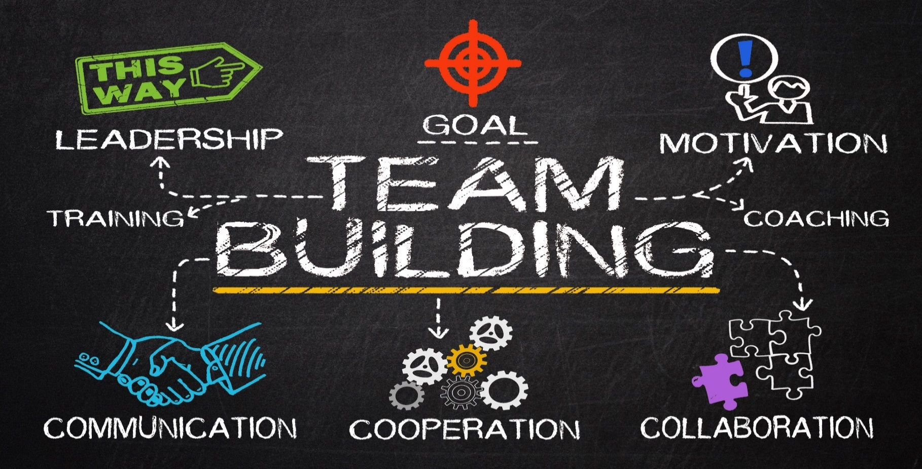

5
Star Bonus.

Enroll 2 new team members at 120CV or more, one at each leg, at the same calandary month. get one-time extra bonus.

2 Basic 120 CV $50
2 Supreme 300 CV $100
2 Business 600 CV $200
2 Ambassador 900 CV $300

- You can win star bonus one time each calandary month.
- If the two new members enroll in two different startup packages, this commission will be paid according to the lower of the two packages.
For example: you enroll one Business and one Ambassador you will be paid star bonus of $ 200

You start wherever you are, But life can take you
to the stars

6
Consistency Rank Bonus.

Once you have reached a rank, and maintain a rank for two consecutive months, receive a one-time bonus.

Rank | CV in the  lesser leg | First generation | Consistency  Rank bonus
Bronze | 1,000 |  | $ 200
Silver | 2,000 | 2 Star | $ 300
Gold | 4,000 |  | $ 500
Pearle | 8,000 |  | $ 1,000
Sapphire | 16,000 | 2 Silver | $ 1,500
Ruby | 32,000 |  | $ 2,000
Emerald | 64,000 |  | $ 3,000
Diamond | 100,000 | 2 Sapphire | $ 5,000
Blue Dimond | 150,000 | 3 Sapphire | $ 10,000
Black Diamond | 200,000 | 4 Sapphire | $ 25,000
Double Diamond | 300,000 | 6 Sapphire | $ 50,000

Leaders Pool Bonus.

7

Up to 7% of the company's world revenue will be divided among all leadership ranks according to the following key:

Percentage of total company  World revenue divided between |  | All have these ranks
Sapphire Pool | 1% | Sapphire
Ruby Pool | 1% | Ruby
Emerald Pool | 1% | Emerald
Diamond Pool | 1% | Diamond
Blue Diamond Pool | 1% | Double Diamond
Black Dimond Pool | 1% | Blue Dimond
Crown Dimond Pool | 1% | Crown Dimond

Note: The amount of each pool (1%) will be divided between a minimum of 4 people. This means that the maximum commission is 0.25% of the global company's revenue

w

Our Education System

Knowledge is the key to long-term success.

We are committed to bringing you all the essential knowledge you need for your success. We have created for you a series of courses and a comprehensive curriculum.

Natural Herbal Studies

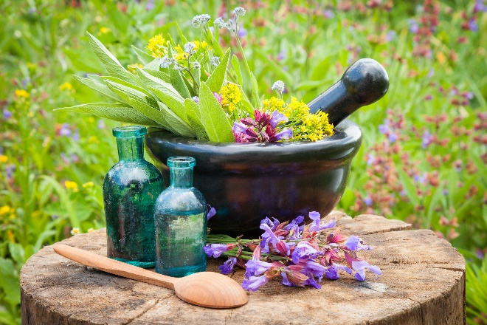
The use of Herbal Extacts for ripening and balancing has been known in human culture for thousands of years.

The active ingredients extracted from plants have a direct impact on the quality of all areas life, body, mind, and spirit.

For thousands of years humans have accumulated comprehensive knowledge about the impact of each and every Herb.

Herbs are the source of a large part of the drugs known to us today, the complete herb in its natural composition has an advantage in the synergy between the ingredients that helps for optimal health

We have created for you, a comprehensive curriculum (basic and advanced courses) in Natural Herbal, with an emphasis on how to use Natural Herbal Extracts, to improve the quality of life in all areas, Body, Mind and Spirit.

Note: For those who enroll in executive packages (Business and Ambassador) all Natural Herbal Studies are for free

Affiliate Marketing Studies

Social media marketing is the most powerful marketing tool today and will be even more powerful in the future.

The world of online commerce allows you to have the whole world in the palm of your hand.

We teach you how to market our products worldwide on social media. This way you are able to earn and build yourself a successful home business.
Our system can allow you to reach a particularly high income and even the opportunity to earn passive income while helping other people succeed and earn.

Our Personal Development Program

Be More, Do More, Have More

Our powerful personal development program supports you to be the best In every area of your life.

First step: The Butterfly Effect Training
A powerful experiential training program. Three days of learning and coaching, developing an abundant mind set, seeing everything as an opportunity, learning How to win all your points of failure, how to be the best and assisting to create a life of freedom, power, abundance, and love

Step Two: The Power Training
A powerful personal training program, to discover the joy inside of us, and pave the way for success and fulfillment

Step Three: Trainers and Leaders Training
A comprehensive program for training coaches and leaders in all areas of life, both personal and business.

Creating a better world for us
and for the generations to cam

Our Corporate team

We are committed to your success

President

CEO

International Marketing

Product Development

IT Systems

Come build a future with us

Natural Selection Company Ltd. (Natural Selection)
We distribute our products through a network of independent distributors

The distributor network is designed to expand steadily In all countries where the company is active around the world.

The independent distributor operating within the company entitled to commissions according to our commission plan described here.

In order to work with Natural Choice or with the company's subsidiaries around the world and be entitled to commissions

The candidate applying to be an independent distributor, submit a signed application to be accepted as an independent distributor in the company, indicate who the person who invited him to be an independent distributor in the company (sponsor), agree and sign the distributors agreement and undertake to comply with the company's terms and conditions.

And obtain the Company's approval for the application received

